Raman data processing GUI

This document describes all the steps needed to go from raw .bin data file collected at Sandia to useful temperature and species profiles, using two GUI. The software is primarily intended for use with Sandia acquired data.

# Folder Organization

Data collected at sandia are typically stored on Drobo on a folder named for the day the data were acquired. Copy the folder to your personal laptop, or to the Data folder (E:\data\) on TCL server. If this is your first time processing data using the GUI, copy the calibration folder provided with the code inside the folder containing the data you are going to analyze. Also create a folder named Output where that will contain all the .mat output files.

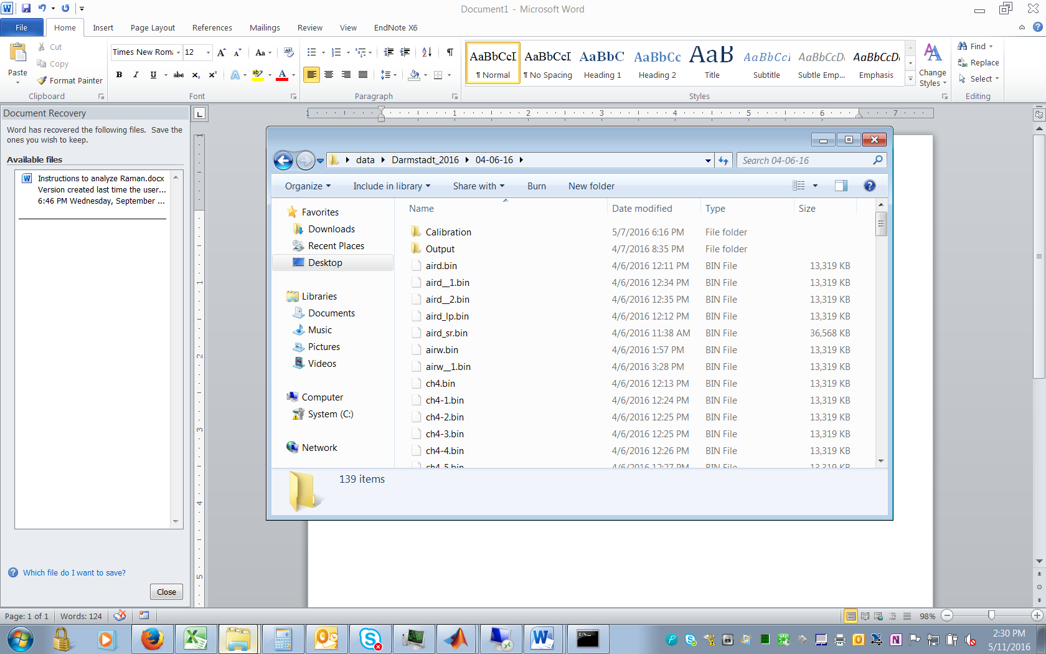

At the end your data folder should look like this. A good practice is to have a reference Calibration folder in the subdirectory containing all data from a measurement campaign (Darmstadt 2016 in this example). When analyzing data from any specific day, this folder will provide a starting point for all the parameters. Later in this manual, details on how to create this reference calibration folder are provided.

Also copy the laminar calculations folder provided with the software to you desired location.

# Running the software for the first time

If this is the first time you run this software there are some one-time preliminary steps to perform. Move the Software folder in your preferred location. Open Matlab. In Home/Set Path add the folder where you placed all the .m files and all its subfolders.

In the Matlab command window type **guide**. Matlab will ask you for the GUI to open; select Calibration GUI. DO NOT RUN THE GUI YET. 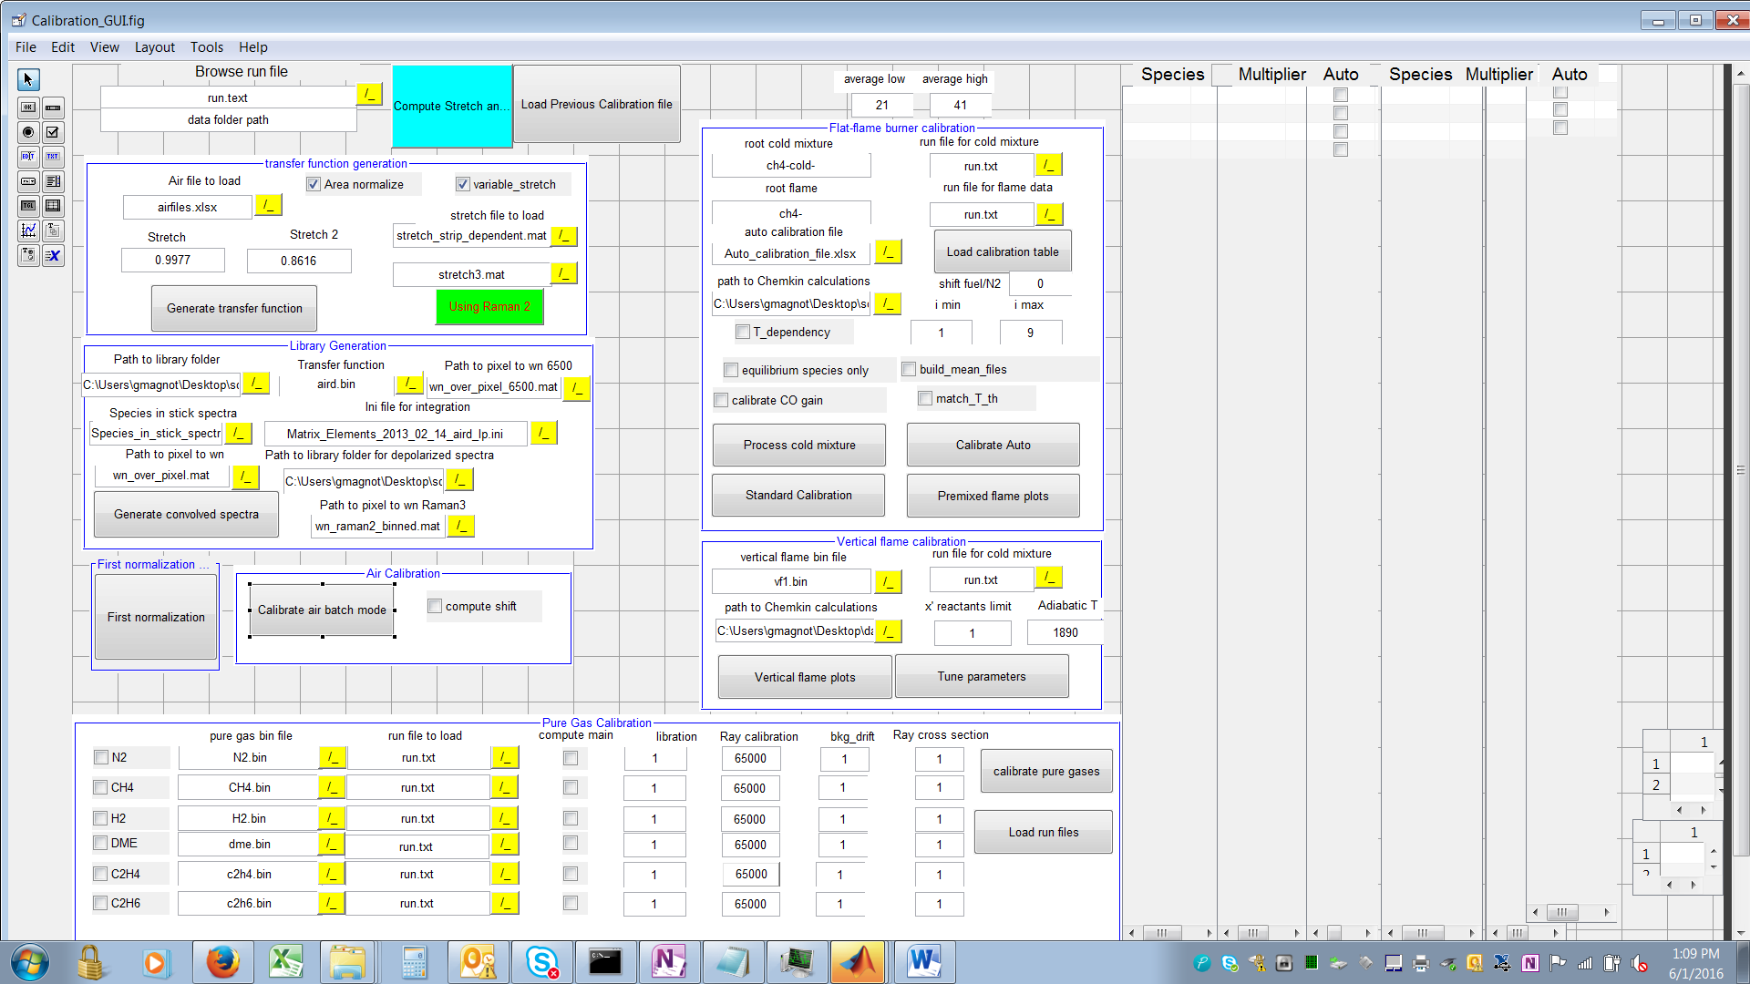

Double click on the textbox under Path to Library folder, and change the “String” entry to the address of the folder “Library Spectra” on your computer (you need to replace only the first portion of the address). Repeat the same for Path_to Chemkin and path_to_chemkin_calculations (in the flat flame and vertical flame windows), but point to the laminar files folder on your computer. Remember to save the file so that the new addresses are the default ones.

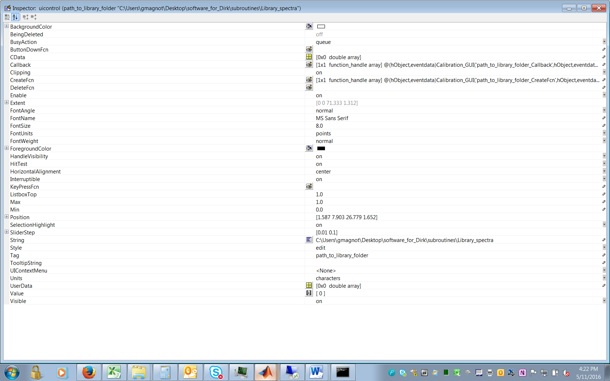

Type **‘guide’** on the Matlab command window and load the ‘Stretch.fig’ gui.

Similarly change the Path_to_library folder to your path to library, so that it becomes the new dfefault.

# Creating Stick Spectra from Ramses for the first time, or after realignment of the Raman camera

This is a step to be performed only after changes to the optical setup, and involves using the Ramses code. There is a folder in the GUI package named “*Ramses input files*”, The folder contains a file names *Ramses.ini*, containing the input files for Ramses, and a file named “*Sandia_Apr_2016_hr_quad_spline*”. Copy these 2 files in the folder containing the Ramses .exe file. Open the Ramses.ini files and change all the paths to match the corresponding locations on your folder. I prefer generating the libraries for each species one at the time. For N2, CO and H2 the rotational S branch should work. It does not work for all other species so make sure is off when computing libraries for CO2, O2 and H2O. In the *dispersion* section of the ramses ini file, make sure option 2 is selected and the ‘*Sandia_Apr_2016_hr_quad_spline.dat*” file is chosen. Set concentration of CO2 to 1 and all the others to 0. Set rotational Raman branch o and s to 0. Save the file.

Run ramses.exe from command prompt. Select option 4 (select linewidth) and choose Gaussian (option 3) with linewidth=1.0 (remember the decimal .0). Then select option 1 (generate libraries with concentration specified in ini file). The code will generate “stick” spectra that are stored in the results folder. Run the matlab file : “convert_stick_spectra_to_wn” included in the *Ramses input file* folder after opportunely modifying the path to the library and Ramses folder. This will generate files containing the wavelength and the spectra at row 27 for each species and store them in your_path/Library_spectra/stick_spectra. These are the files used in the library generation step.

# Calibration Procedure

## Prepare the I/O folders

Type **guide** in the command window and load Raman.gui. Run the gui by clicking the green arrow or by selecting Tools/Run. Description of the input files required by the Ramn gui is provided later in the manual.

Press **load run**. The gui will ask for a .txt run file. Point to the aird_run.txt file located in the Calibration folder (inside the folder containing the data you are going to analyze, as described above in section 1 Folder Organization ). The run file you selected was generated for a different dataset, and it is pointing to the wrong folder.

**In all my GUI the symbol /. next to a text box open a dialog window where you can select a folder or a path**

Change the parameters in the I/O folder path sub-section (upper-left corner), by pressing the **/.** button associated tothe Input-folder path, Calibration folder path and Output folder path.

The red **Update** button is now visible. Click on it and it will overwrite the aird_run.txt file with the new folder locations.

Run the Calibration GUI by pressing the green arrow or Tools/Run. Load the initial run file (aird_run.txt), by pressing the **/.** button under browse run file. You`ll see the data folder text box being updated and the Species and Multiplier columns to the right being filed.

## Spectrally resolved data analysis

Press the Stretch button to open a GUI dedicated to the analysis of the spectrally resolved data. The GUI determines the factor by which the instrument function is modified (stretch factor) to provide the best fit to N2 spectrum in air. The stretch factor is strip dependent. The code also determines the pixel shift (strip_dependent contribution + overall shift) defined as the difference between the peak of the N2 theoretical, convolved spectrum and the experimental N2 spectrum.

To run the code, first verify that the path_to_library is pointing to the right folder (your_path\Library_spectra). Under browse run file select the run file you modified in the previous step (typically aird_run.txt) and then press **Load run**. Verify that the path_to_pixel to wn and pixel_to wn stick are pointing to the correct files. (They must be the same files used to generate the Ramses spectra, and stored as a copy in Ramses_input_files).

Press **Generate multistrip stretch** and wait until a plot appears You can now compare convolved and experimental spectra at each strip, by selecting the strip number and pressing **Plot at strip number**. The red curve is the experimental data, the green curve shows the convolved data with stretch factor set to 1, and the black the convolved spectra with the optimized stretch factor. The code automatically updates the selected run file (aird_run.txt) with the computed overall pixel shift and with the name of the shift_from_stretch_gui.mat file (default is stretch_fit.mat).

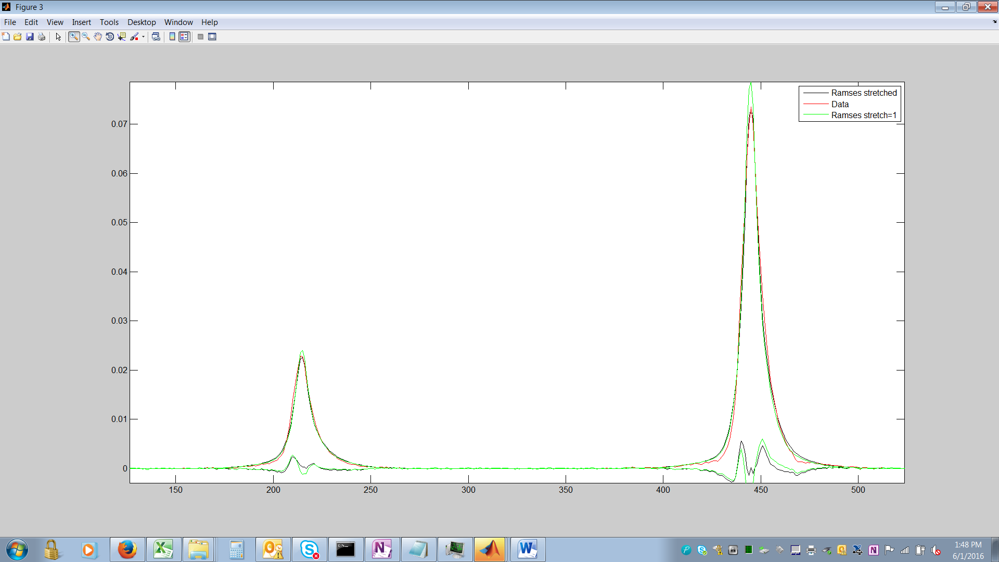

The plot shows a good agreement for the peak location, but it tend to overestimate the signal at the edges.

## Generate the transfer function

The first step is to prepare the airfiles.xlsx file. Typically I modify an airfiles.xlsx already existing in the Calibration folder, but if you need to create one, simply open Excel, and type in the Column A of Sheet 1 the filenames of all the data files collected in air during a test day (for example aird, aird__1, aird__2, …) and in Column B the corresponding dark files (dark.bin, dark__1.bin, …). Always choose the dark that is closest in time to the air file. Close excel, and in air_file_to_load select the recently created/modified airfiles.xlsx file using the browsing button. Note that the airfiles.xlsx files will be used many times during the calibration procedure.

IF the stretch routine was run (recommended whenever the resolved air spectra are available), select the “variable stretch” tick box and the point to the stretch_file_to_load generated in the previous step (stretch_strip_dependednt.mat by default).

Press Generate transfer function. The code will generate as many .spe files as air files in the airfiles.xlsx file, containing a strip-dependent instrument function obtained from the Rayleigh profile. If the Raman 2 or Raman 3 camera were used, it will also generate instrument functions for the Raman2 or raman 3 system based on the Rayleigh 2 camera profile. Column C and D of the airfiles.xlsx file is now populated by the name of the instrument function for Raman 1 and Raman 2/3 respectively. The transfer function box in the Library generation panel is now updated with the airfiles.xlsx filename.

## Create the libraries

The Library generation panel generates one library for each of the air data file listed in the airfiles.xlsx. The section first convolves the Ramses “stick spectra” with the previously created transfer function, then it integrates the spectra over binning regions. The convolved spectra do not account for the bowing effect, but only for the different transfer function at each strip.

The bowing effect is accounted for by changing the integration region for the convolved spectra at each strip. The binning region in the ini file provides for each strip the spectral integration region, based on wn_over_pixel_1300_quad.mat.

Because of the bowing effect, a pixel range corresponds to different spectral ranges for different strips. The code determines the spectral range at strip 27 based on input pixel regions, and then for each strip move t

It requires in input:

the Path_to Library folder, the wavelength-to-pixel-conversion (based on 1300 points) and the wavelength-to-pixel-conversion-stick (based on 6500 points). These path and files should have been already set as default in previous steps, and should not require any changes now. If not, always use the browse buttons, and make sure the wavelength-pixel-conversion correspond to the dispersion file used to create the Ramses stick spectra.